Exercise: iOS Overview – Your first project
Document Number: |  | Issue Number:  Date:

TABLE OF CONTENTS
1 Exercise 1: Create a very simple Android application with Resource 2
1.1 Description 2
1.2 Create new Single View Application 2
1.3 Application Project was created looks like 4
1.4 Add component to view. 6
1.5 Connect Outlets and Actions 7
1.6 Create method changeHelloLabel and implement it. 8
1.7 Try it now 9

Exercise 1: Create a very simple Android application with Resource

Description
The purpose of this exercise is let student understand how to use xcode to develop a simple project.

Create new Single View Application
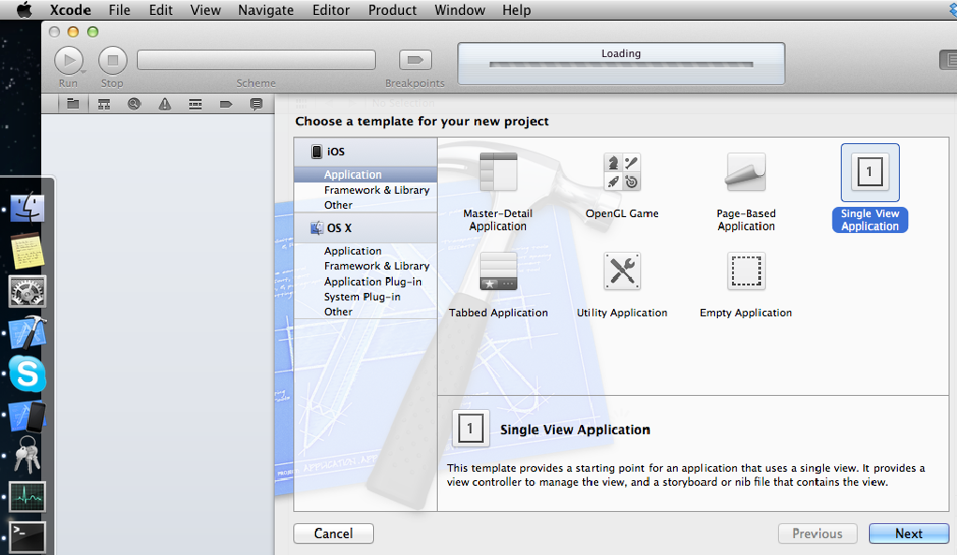

Name Application Name: storyboard and check “Use Storyboards” option
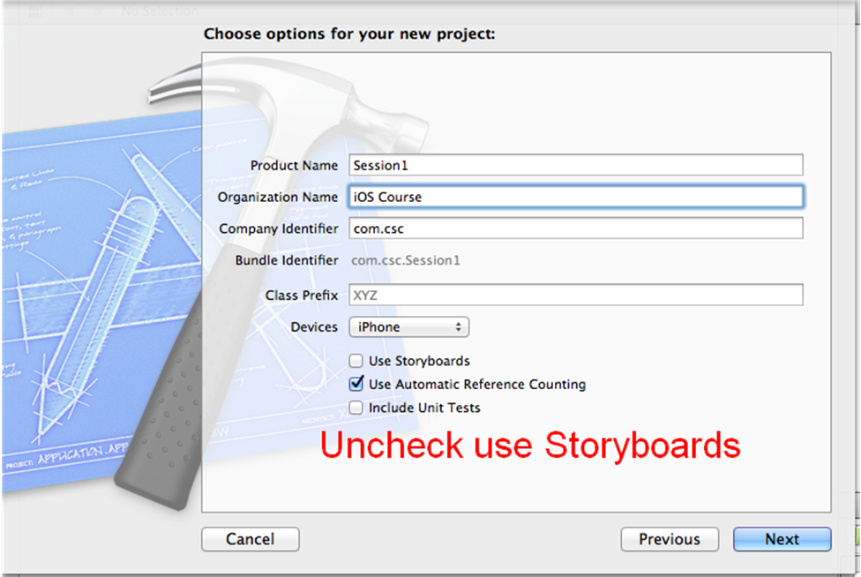

Application Project was created looks like

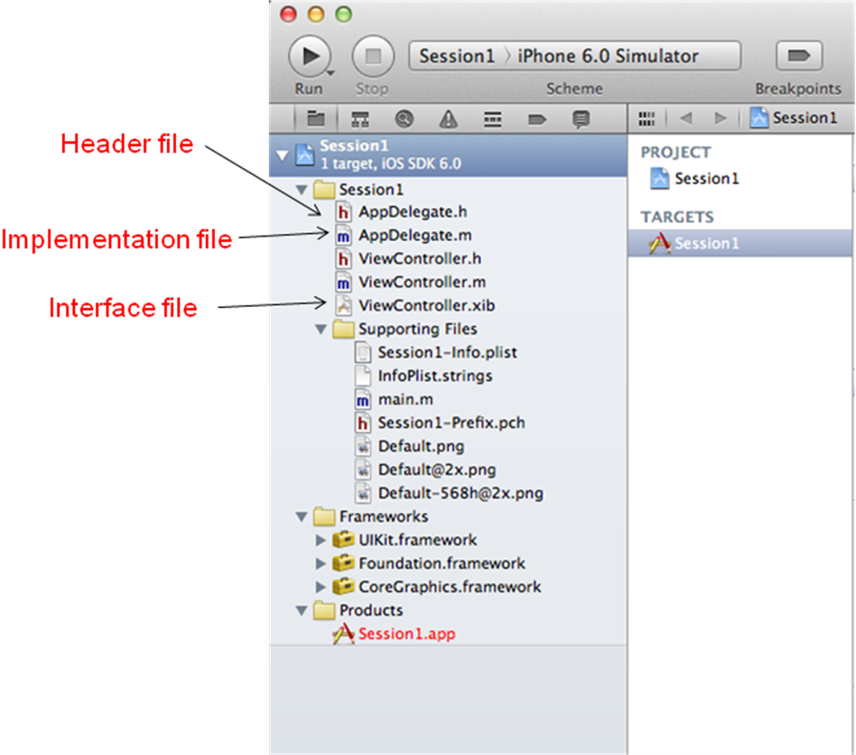

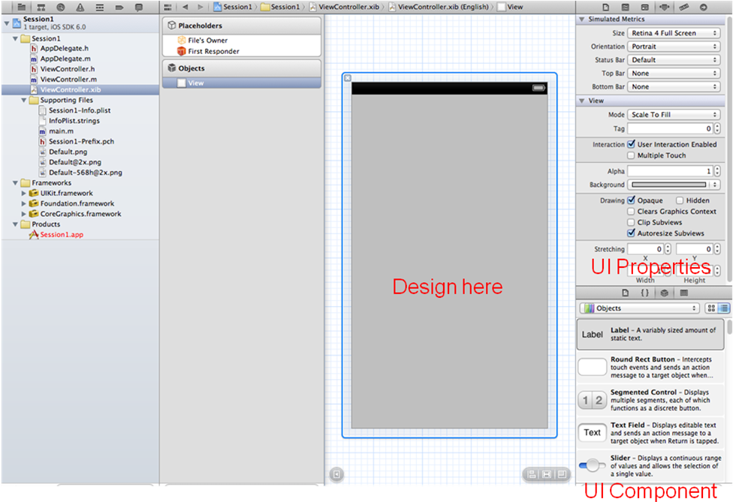

Add component to view.

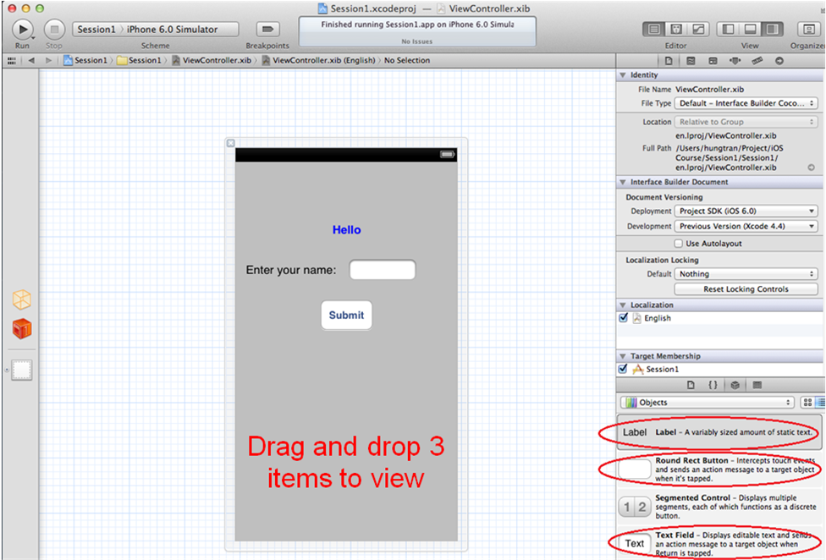

Connect Outlets and Actions
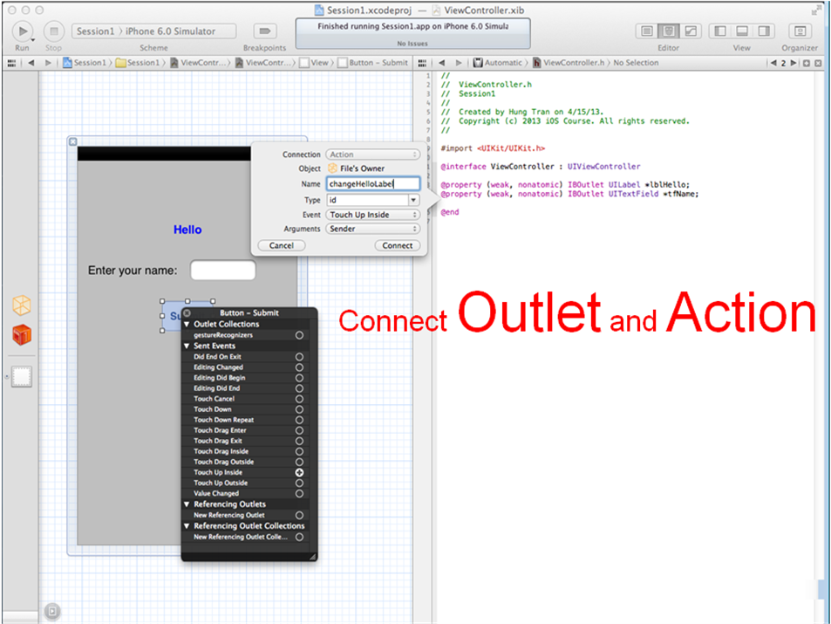

Create method changeHelloLabel and implement it.
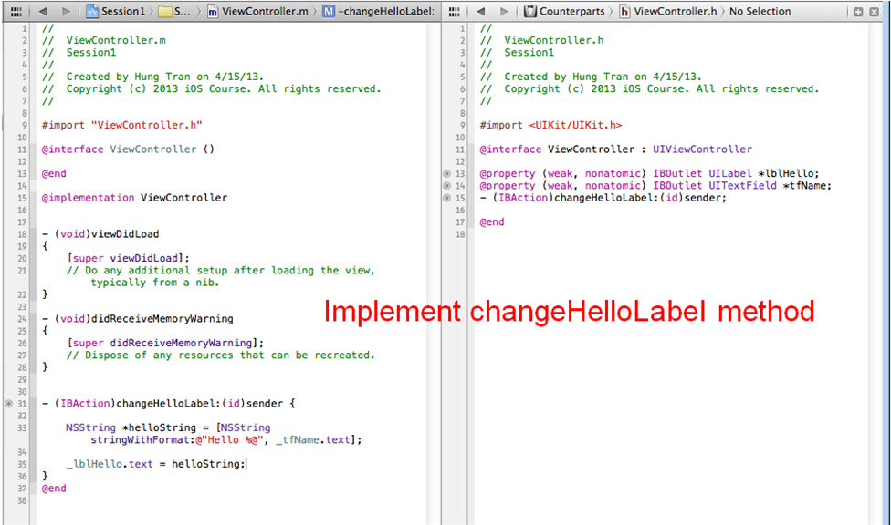

Try it now

